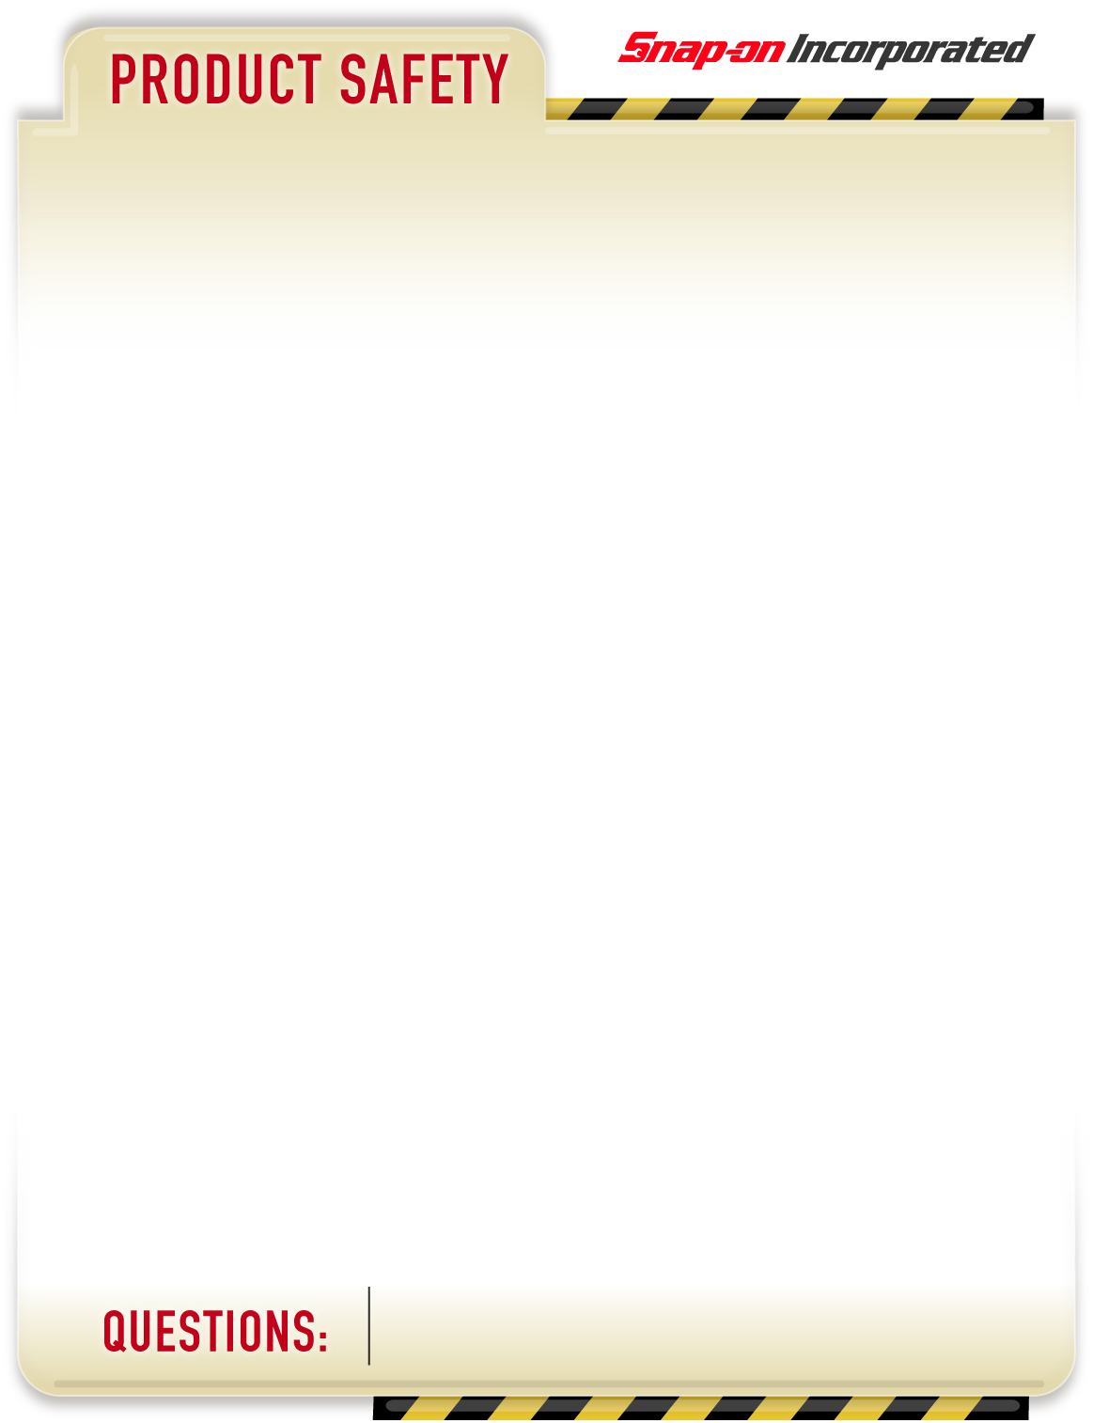

**PRODUCTS AFFECTED**:

**PART NAME & DESCRIPTION**:

Tool Utility Vehicles (TUV’S)

**PART NUMBER(s)**:

KRLP1022 AND COLORS

KRLP1023 AND COLORS

KRLT1022 AND COLORS

KRLT1023 AND COLORS

KRLR1022 AND COLORS

**ACTIONS**:

Please replace the warning label on your Tool Utility Vehicle (TUV) with the enclosed warning label. Unfortunately, the warning label assembled to your unit is missing the graphical icons in the warning symbols.

 

INCORRECT CORRECT



Top of Form

**ADVISORY**

September 15, 2010

If you have questions on this advisory or need assistance contact: Dan Voelz at (262) 656-6073.

Page 1 of 1