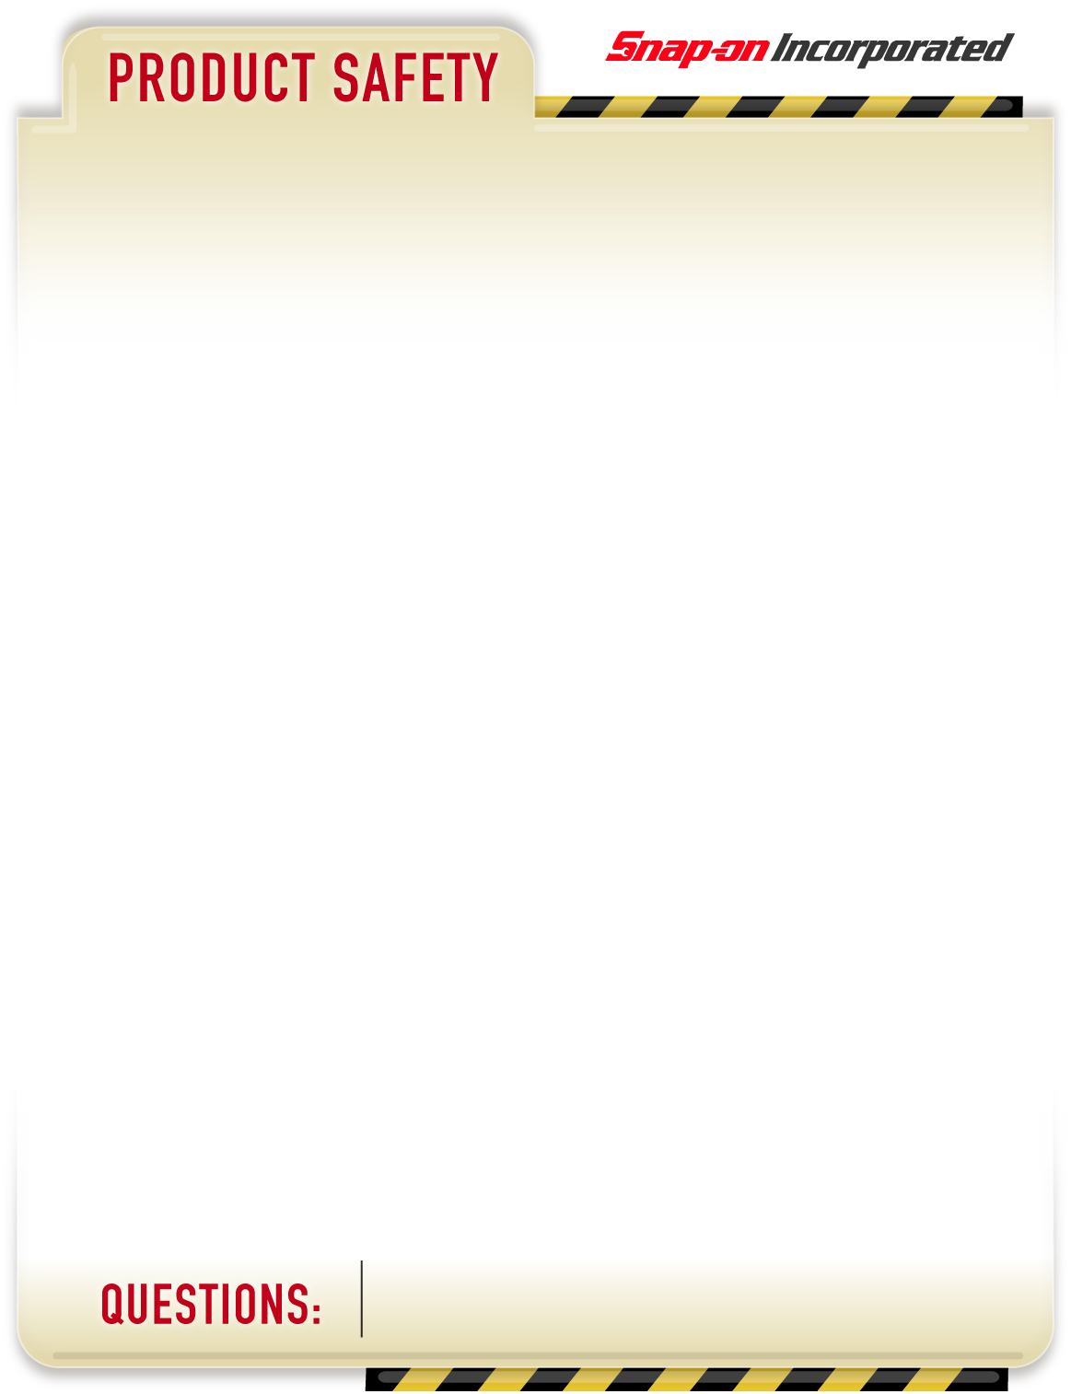

February 27, 2012

**PRODUCTS AFFECTED**: Blue-Point Battery Maintainer

PART NUMBER(s):

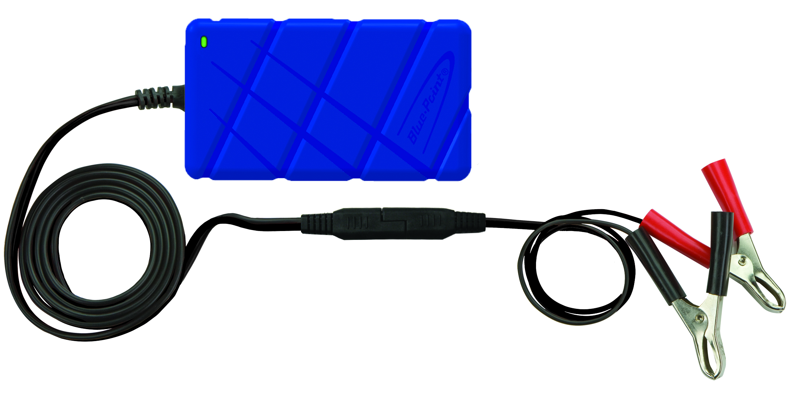

**HAZARD**:

The safety defect involves a potential short circuit between the vehicle battery and the maintainer when charging the battery. The heat generated by the short circuit could cause the plastic and/or output cables to melt, increasing the risk of fire.

**ACTIONS**:

1. You should immediately discontinue using the Blue-Point Battery Maintainer, model EEBM100, and return it to Clore Automotive.
2. Call Clore Automotive customer service at 800-328-2921 or go to [www.cloreinfo.com/return](http://www.cloreinfo.com/return) and complete form to request a prepaid UPS mailing label to return the product.
3. To confirm that your maintainer is one of these models, look for the model number on the product located on the back of the unit.

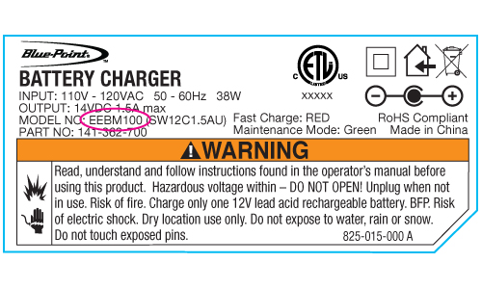

1. Upon receipt of the return of your Blue-Point battery maintainer, **Clore Automotive will ship to you free of charge, a new Snap-on model EEBM500**. It has 4 amps with added features and can be reviewed at [www.snapon.com](http://www.snapon.com) .

**EEBM100**

RECALL

Top of Form

**ADVISORY**

If you have questions on this advisory or need assistance contact: Clore Automotive at 1-800-328-2921.

Page 1 of 1