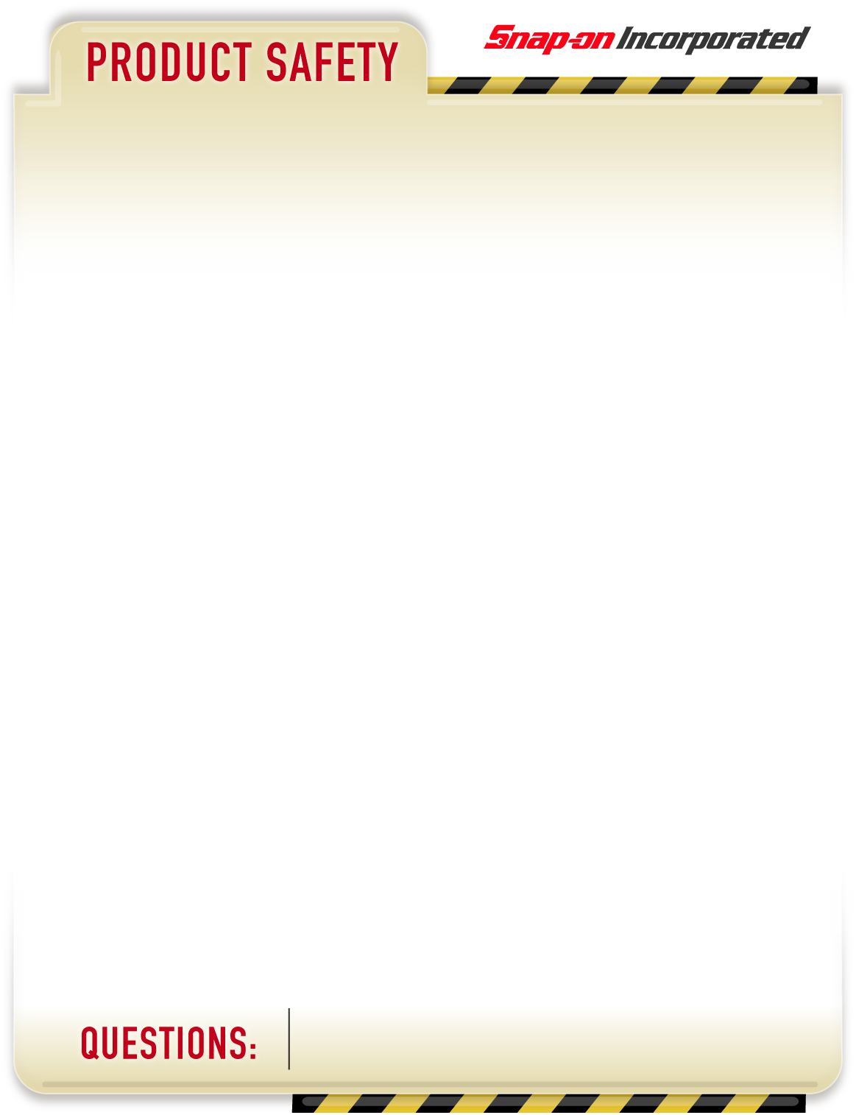

**SAFETY RETROFIT**

If you have questions on this advisory or need assistance contact: Customer Service at (800) 362-4619.

**PRODUCTS AFFECTED**:

All Open Front 4-Post Lifts with 1" Threaded Cylinder Piston Rod Ends made by Wheeltronic / Snap-on Equipment and distributed under the following brands: John Bean, Hofmann, Wheeltronic, Hennessy Industries, American Tire Distributors and Accu Industries.

**PART NAME & DESCRIPTION**:

Automotive Lift used for General Service and Vehicle Alignment

Open Front 4-Post Lifts - 172" and/or 210" Wheelbase capabilities, with 24" wide runways.

**HAZARD**:

**During raising or lowering of the lift, the threaded cylinder piston rod end may fracture, causing the lift to suddenly drop. This may cause serious personal injury or death.**

**ACTIONS**:

Snap-on Equipment is voluntarily replacing hydraulic cylinders used in production of open front 4-Post lifts manufactured from 1997 to 2008.

**January 2011**

Page 1 of 3



Page 2 of 3

If you have questions on this advisory or need assistance contact: Customer Service at (800) 362-4619.

**PART NUMBER(s)**:

|  |  |
| --- | --- |
| Brand | Models - **includes models that end “-M”** |
| John Bean | 44212OQ, 44212OQE, 44214Q, 44214QE |
| Hofmann Industries | FPOA12172, FPOA12210, FPOA14172, FPOA14210 |
| Wheeltronic | 12407AF, 12407AFX, 12407CW, 12407XCW, 14407AF, 14407AFX, 14407CW, 14407XCW |
| Hennessy Industries | S412OSA_ _ _, S412OSS_ _ _, S412OXA_ _ _, S412OXS_ _ _, S414OA_ _ _, S414OSA_ _ _, S412OXA_ _ _, |
| American Tire Distributors (ATD) previously operating as Heafner Tire | WH-12407_ _, WH-120EAL, WH-120EALH, WH-812407AFX, WH-120EXTCW, WH-120EXTCWH, WH-12FD, WH-12Q210 |
| Accu Industries | AC12407AF, AC12407AFM, AC12407AFXM, AC12407XT |
| Snap-on | EELR121A, EELR121AEXT, EELR121EXTP, EELR121APKG |

Please inspect the Model Number/Serial Number tag on the lift (See Fig. 1 on the next page).

**Do not stand on or under the lift unless lift platform is properly seated on the lift column safety locks. Operators and bystanders need to be clear of the lift during raising and lowering.**

**Operators must continue maintenance and periodic lift inspections as per product manuals, product advisories and ANSI/ALI ALOIM, ANSI/ALI ALIS standards for automotive lifts.**

**Please affix the enclosed warning sticker to the lift column in the location identified in Figure 1.**

If your lift model has been identified by this Product Safety Retrofit and was manufactured prior to January 1st, 2009, Snap-on Equipment will be contacting you to schedule a cylinder replacement.

Continue

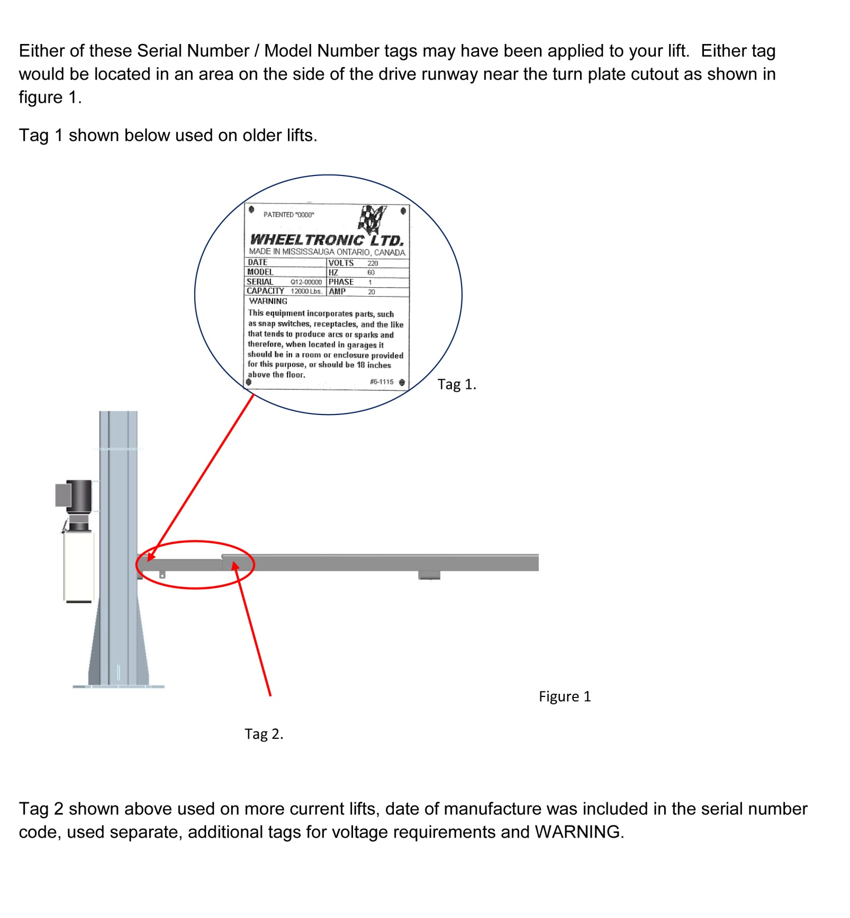

Serial:

Capacity:

Made in Mississauga, Ontario, Canada – Wheeltronic Ltd.

Model:

**Place warning sticker here.**

If you have questions on this advisory or need assistance contact: Customer Service at (800) 362-4619.

Page 3 of 3